Java Notes
Introduction
- Java is a popular high-level,object-oriented programming language that was originally developed by Sun Microsystems and released in 1995. Currently, Java is owned by Oracle, and more than 3 billion devices run Java.
- Java runs on a variety of platforms, such as Windows, Mac OS, and the various versions ofUNIX.
- Today Java is being used to develop numerous types of software applications, including desktop apps, mobile apps, web apps, games, and much more.
- Java is a pure object-oriented language, and everything in Java is an object. Java supports OOPS principles like Inheritance, Encapsulation, Polymorphism, Classes , and so on.
- Java code is platform independent. Java code is not compiled into machine-specific code; it is compiled into a platform-neutral byte code. This byte code is executed by JVM which runs the code on the underlying platform. This capability makes Java a Write Once Run Anywhere language. This means that compiled Java code can run on all platforms that support Java without the need to recompile. Java code written on a Windows machine can be executed without any code change on MacOS and vice versa. There is no need to make any operating system-specific code changes.
- Java byte code can be executed on any kind of processor. JRE automatically handles the code execution on different types of processors.
- Java is secure by architecture. A developer is not required to directly interact with the underlying memory or operating system. Java provides automatic garbage collection, so developers are not required to worry about memory leaks, management, etc.
- Java is both compiled and interpreted: it is first compiled into bytecode, then interpreted or just-in-time compiled by the JVM at runtime.
- Fun fact: Java was named after coffee because the developers drank tons of it while coding, and thought "Java" sounded cool and energizing!

Java Virtual Machine (JVM)
- The JVM (Java Virtual Machine) is a virtual machine, an abstract computer that has its own ISA, memory, stack, heap, etc. It runs on the host OS and places its demands for resources on it.
- The JVM (Java Virtual Machine) is a specification and can have different implementations, as long as they adhere to the specs. The specs can be found in the below link − https://docs.oracle.com
- Oracle has its own JVM implementation (called the HotSpot JVM), the IBM has its own (the J9 JVM, for example).
- The operations defined inside the spec are given below (source − Oracle JVM Specs)
  - The 'class' file format
  - Data types
  - Primitive types and values
  - Reference types and values
  - Run-time data areas
  - Frames
  - Representation of objects
  - Floating-point arithmetic
  - Special methods
  - Exceptions
  - Instruction set summary
  - Class libraries
  - Public design, private implementation
- The architecture of the HotSpot JVM 3 is shown below –
- 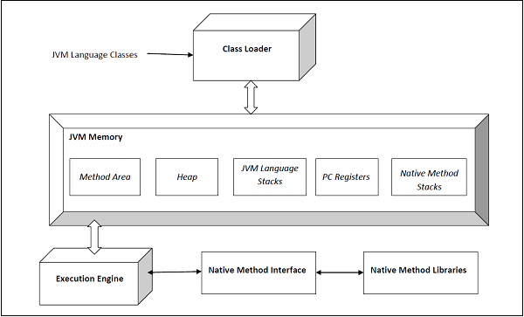
- The execution engine comprises the garbage collector and the JIT compiler. The JVM comes in two flavors − client and server. Both of these share the same runtime code but differ in what JIT is used. We shall learn more about this later. The user can control what flavor to use by specifying the JVM flags -client or -server. The server JVM has been designed for long-running Java applications on servers.
- The JVM comes in 32b and 64b versions. The user can specify what version to use by using -d32 or -d64 in the VM arguments. The 32b version could only address up to 4G of memory. With critical applications maintaining large datasets in memory, the 64b version meets that need.
- Components of JVM (Java Virtual Machine) Architecture
- Class Loader Subsystem
  - The JVM manages the process of loading, linking and initializing classes and interfaces in a dynamic manner. During the loading process, the JVM finds the binary representation of a class and creates it.
  - During the linking process, the loaded classes are combined into the run-time state of the JVM so that they can be executed during the initialization phase. The JVM basically uses the symbol table stored in the run-time constant pool for the linking process. Initialization consists of actually executing the linked classes.
  - The following are the types of class loaders:
    - BootStrap class loader: This class loader is on the top of the class loader hierarchy. It loads the standard JDK classes in the JRE's lib directory.
    - Extension class loader: This class loader is in the middle of the class loader hierarchy and is the immediate child of the bootstrap class loader and loads the classes in the JRE's lib\ext directory.
    - Application class loader: This class loader is at the bottom of the class loader hierarchy and is the immediate child of the application class loader. It loads the jars and classes specified by the CLASSPATH ENV variable.
    - Custom Class Loaders: User-defined for dynamic or isolated class loading.
  - The linking process consists of the following three steps:
    - Verification − This is done by the Bytecode verifier to ensure that the generated .class files (the Bytecode) are valid. If not, an error is thrown and the linking process comes to a halt.
    - Preparation − Memory is allocated to all static variables of a class and they are initialized with the default values.
    - Resolution − All symbolic memory references are replaced with the original references. To accomplish this, the symbol table in the run-time constant memory of the method area of the class is used.
  - Initialization is the final phase of the class-loading process. Static variables are assigned original values and static blocks are executed.
- Runtime Data Areas
  - The JVM spec defines certain run-time data areas that are needed during the execution of the program. Some of them are created while the JVM starts up. Others are local to threads and are created only when a thread is created (and destroyed when the thread is destroyed). These are listed below –
    - PC (Program Counter) Register
      - It is local to each thread and contains the address of the JVM instruction that the thread is currently executing.
    - Stack
      - It is local to each thread and stores parameters, local variables and return addresses during method calls. A StackOverflow error can occur if a thread demands more stack space than is permitted. If the stack is dynamically expandable, it can still throw OutOfMemoryError.
    - Heap
      - It is shared among all the threads and contains objects, classes' metadata, arrays, etc., that are created during run-time. It is created when the JVM starts and is destroyed when the JVM shuts down. You can control the amount of heap your JVM demands from the OS using certain flags (more on this later). Care has to be taken not to demand too less or too much of the memory, as it has important performance implications. Further, the GC manages this space and continually removes dead objects to free up the space.
    - Method Area
      - This run-time area is common to all threads and is created when the JVM starts up. It stores per-class structures such as the constant pool (more on this later), the code for constructors and methods, method data, etc. The (Java Language Specification) JLS does not specify if this area needs to be garbage collected, and hence, implementations of the JVM may choose to ignore GC. Further, this may or may not expand as per the application's needs. The JLS does not mandate anything with regard to this.
    - Run-Time Constant Pool
      - The JVM maintains a per-class/per-type data structure that acts as the symbol table (one of its many roles) while linking the loaded classes.
    - Native Method Stacks
      - When a thread invokes a native method, it enters a new world in which the structures and security restrictions of the Java virtual machine no longer hamper its freedom. A native method can likely access the runtime data areas of the virtual machine (it depends upon the native method interface), but can also do anything else it wants.
- Execution Engine
  - The execution engine is responsible for executing the bytecode, it has three different components:
    - Garbage Collection
      - The JVM manages the entire lifecycle of objects in Java. Once an object is created, the developer need not worry about it anymore. In case the object becomes dead (that is, there is no reference to it anymore), it is ejected from the heap by the GC using one of the many algorithms serial GC, CMS, G1, etc.

      - During the GC process, objects are moved in memory. Hence, those objects are not usable while the process is going on. The entire application has to be stopped for the duration of the process. Such pauses are called 'stop-the-world' pauses and are a huge overhead. GC algorithms aim primarily to reduce this time.
    - Interpreter
      - The interpreter interprets the bytecode. It interprets the code fast but it's slow in execution.
    - JIT Complier
      - The JIT stands for Just-In-Time. JIT compiler compiles the bytecode of the often-called methods into native code at run-time. Hence it is responsible for the optimization of the Java programs.
      - JVM automatically monitors which methods are being executed. Once a method becomes eligible for JIT compilation, it is scheduled for compilation into machine code. This method is then known as a hot method. This compilation into machine code happens on a separate JVM thread.
      - As a result, it does not interrupt the execution of the current program. After compilation into machine code, it runs faster.
- Java Native Interface (JNI)
  - It acts as an interface between the Java code and the native (C/C++) libraries.
  - There are situations in which Java alone doesn’t meet the needs for your application, for example, implementing a platform-dependent feature.
  - In those cases, we can use JNI to enable the code running in the JVM to call. Conversely, it enables native methods to call the code running in the JVM.
- Native Method Libraries
  - These are platform specific libraries and contains the implementation of native methods.
JRE
- The JRE is a package that provides the libraries, JVM, and other components to run Java applications.
- What it contains:
  - JVM (to execute Java bytecode)
  - Core libraries (like java.lang, java.util)
  - Supporting files (property files, configuration files, etc.)
- JRE is needed to run Java programs but does not include development tools like compilers or debuggers.

JDK
- The JDK is a full-featured software development kit to develop and run Java programs.
- What it contains:
  - JRE (so it can run Java programs)
  - Development tools (like javac compiler, javadoc, jar, debuggers, profilers, etc.)
  - Additional libraries and tools for development
- JDK is for developers who want to write, compile, debug, and run Java programs.

JVM vs JRE vs JDK
Name | Purpose | Contains | Platform Independence
JVM | Runs Java bytecode | Execution engine only | JVM is platform independent.
JRE | Runs Java applications | JVM + core libraries like java.lang, java.util, etc. | JRE is platform dependent.
JDK | Develops and runs Java programs | JRE + development tools like javac (The Java compiler that converts .java source files into .class bytecode files), javadoc (Generates API documentation from Java source code comments), jdb (The Java debugger for stepping through code, setting breakpoints, and inspecting variables), etc. | JDK is platform dependent i.e for different platforms different JDK required.

Hello World
- 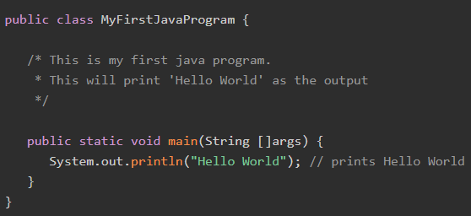
- Steps to Write, Save, and Run Hello World Program
  - Open notepad and add the code as above.
  - Save the file as "MyFirstJavaProgram.java".
  - Open a command prompt window and go to the directory where you saved the class. Assume it's C:\.
  - Type 'javac MyFirstJavaProgram.java' and press enter to compile your code. If there is no error in your code, the command prompt will take you to the next line (Assumption The path variable is set. Learn: Java Envionment Setup).
  - Now, type 'java MyFirstJavaProgram' to run your program.
  - You will be able to see "Hello World" printed on the screen.
  - Output:
  - 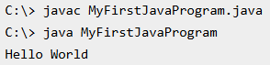
- 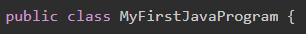
  - This line is creating a new class MyFirstJavaProgram and being public, this class name must be the same as the file name (including case) and the file must have a .java extension. This convention helps Java compiler to identify the name of public class to be created before reading the file content.
- 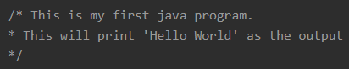
  - These lines being in /* */ block are not considered by Java compiler and are comments. A comment helps to understand program in a better way and makes code readable and understandable.
  - This line represents the main method that JVM calls when this program is loaded into memory. This method is used to execute the program. Once this method is finished, program is finished in single threaded environment.
  - Let's check the purpose of each keyword in this line.
    - public − defines the scope of the main method. Being public, this method can be called by external program like JVM.
    - static − defines the state of the main method. Being static, this method can be called by external program like JVM without first creating the object of the class.
    - void − defines the return type of the main method. Being void, this method is not returning any value.
    - main − name of the method
    - String []args − arguments passed on command line while executing the java command.
  - System.out represents the primary console and its println() method is taking "Hello World" as input and it prints the same to the console output.

Comments
- Single Line Comment
  - 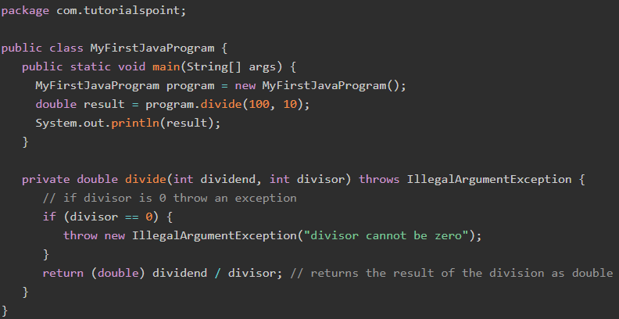
- Multiline Comment
  - 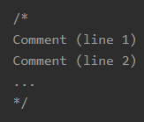
  - 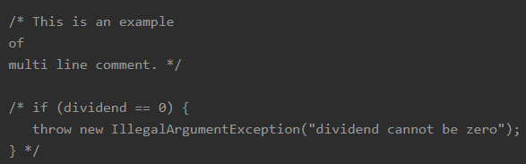
- Documentation Comment
  - The documentation comments are used for writing the documentation of the source code. The documentation comments start with a forward slash followed by the two asterisks (/**), end with an asterisk followed by a backward slash (*/), and all lines between the start and end must start with an asterisk (*).
  - The documentation comments are understood by the Javadoc tool and can be used to create HTML-based documentation.
  - 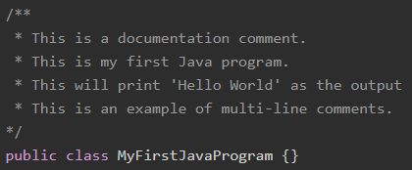
  - 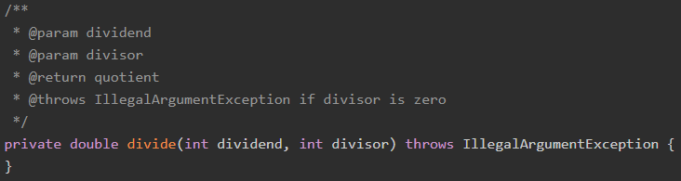

Basic Syntax
- Case Sensitivity − Java is case sensitive, which means identifier Hello and hello would have different meaning in Java.
- Class Names − For all class names the first letter should be in Upper Case. If several words are used to form a name of the class, each inner word's first letter should be in Upper Case. Example: class MyFirstJavaClass
- Method Names − All method names should start with a Lower Case letter. If several words are used to form the name of the method, then each inner word's first letter should be in Upper Case. Example: public void myMethodName()
- All Java components require names. Names used for classes, variables, and methods are called identifiers.
- In Java, there are several points to remember about identifiers. They are as follows −
  - All identifiers should begin with a letter (A to Z or a to z), currency character ($) or an underscore (_).
  - After the first character, identifiers can have any combination of characters.
  - A keyword cannot be used as an identifier.
  - Most importantly, identifiers are case sensitive.
  - Examples of legal identifiers: age, $salary, _value, __1_value.
  - Examples of illegal identifiers: 123abc, -salary.
- Like other languages, it is possible to modify classes, methods, etc., by using modifiers. There are two categories of modifiers −
  - Access Modifiers − default, public , protected, private
  - Non-access Modifiers − final, abstract, strictfp

Variables
- A variable provides us with named storage that our programs can manipulate. Each variable in Java has a specific type, which determines the size and layout of the variable's memory; the range of values that can be stored within that memory; and the set of operations that can be applied to the variable.
- You must declare all variables before they can be used. Java variables are declared by specifying the data type followed by the variable name. To assign a value, use the assignment (=) operator followed by the value. Each declaration or initialization statement must end with a semicolon (;).
- To declare more than one variable of the specified type, you can use a comma-separated list.
- 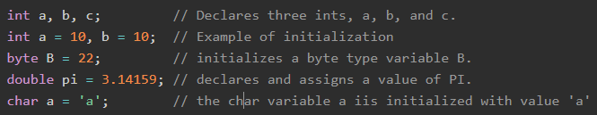
- The following are the three types of Java variables:
  - Local variables
    - Local variables are declared in methods, constructors, or blocks.
    - Local variables are created when the method, constructor or block is entered and the variable will be destroyed once it exits the method, constructor, or block.
    - Access modifiers cannot be used for local variables.
    - Local variables are visible only within the declared method, constructor, or block.
    - Local variables are implemented at stack level internally.
    - There is no default value for local variables, so local variables should be declared and an initial value should be assigned before the first use.
    - Ex:
      - Here, age is a local variable. This is defined inside pupAge() method and its scope is limited to only this method.
      - 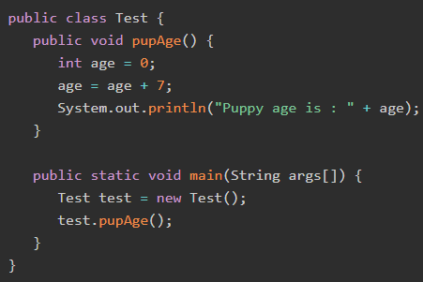
    - Ex:
      - Following example uses age without initializing it, so it would give an error at the time of compilation.
      - 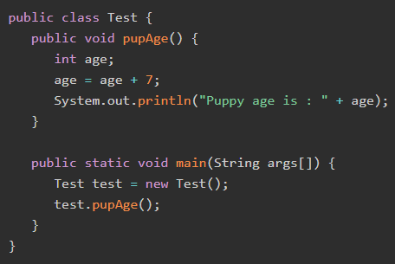
      - Output:
      - 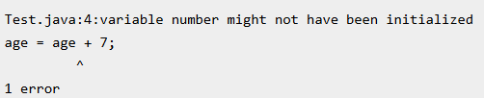
  - Instance variables
    - Instance variables are declared in a class, but outside a method, constructor or any block.
    - When a space is allocated for an object in the heap, a slot for each instance variable value is created.
    - Instance variables are created when an object is created with the use of the keyword 'new' and destroyed when the object is destroyed.
    - Instance variables hold values that must be referenced by more than one method, constructor or block, or essential parts of an object's state that must be present throughout the class.
    - Instance variables can be declared in class level before or after use.
    - Access modifiers can be given for instance variables.
    - The instance variables are visible for all methods, constructors and block in the class. Normally, it is recommended to make these variables private (access level). However, visibility for subclasses can be given for these variables with the use of access modifiers.
    - Instance variables have default values. For numbers, the default value is 0, for Booleans it is false, and for object references it is null. Values can be assigned during the declaration or within the constructor.
    - Instance variables can be accessed directly by calling the variable name inside the class. However, within static methods (when instance variables are given accessibility), they should be called using the fully qualified name. ObjectReference.VariableName.
    - 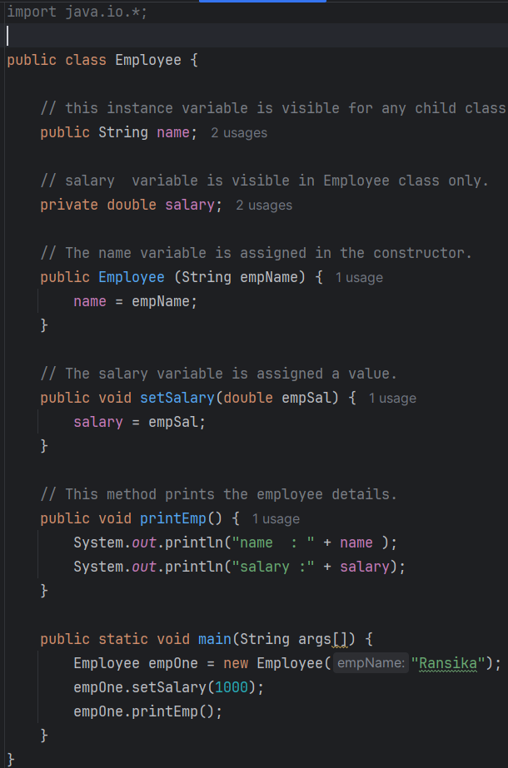
    - Output:
    - 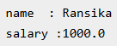
  - Class/Static variables
    - Class variables also known as static variables are declared with the static keyword in a class, but outside a method, constructor or a block.
    - There would only be one copy of each class variable per class, regardless of how many objects are created from it.
    - Static variables are rarely used other than being declared as constants. Constants are variables that are declared as public/private, final, and static. Constant variables never change from their initial value.
    - Static variables are stored in the static memory. It is rare to use static variables other than declared final and used as either public or private constants.
    - Static variables are created when the program starts and destroyed when the program stops.
    - Visibility is similar to instance variables. However, most static variables are declared public since they must be available for users of the class.
    - Default values are same as instance variables. For numbers, the default value is 0; for Booleans, it is false; and for object references, it is null. Values can be assigned during the declaration or within the constructor. Additionally, values can be assigned in special static initializer blocks.
    - Static variables can be accessed by calling with the class name ClassName.VariableName.
    - When declaring class variables as public static final, then variable names (constants) are all in upper case. If the static variables are not public and final, the naming syntax is the same as instance and local variables.
    - Ex:
    - 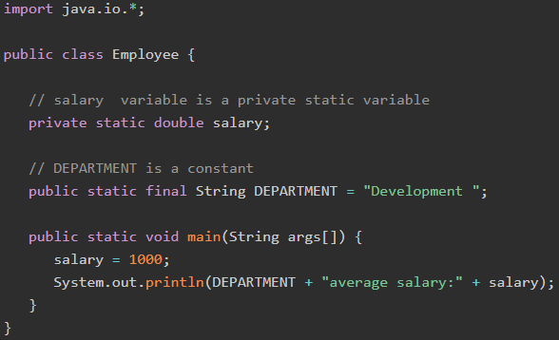
    - Output:
    - Note − If the variables are accessed from an outside class, the constant should be accessed as Employee.DEPARTMENT
Scope
- 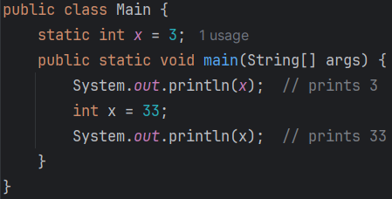

Data Types
- Java data types define the type and value range of the data for the different types of variables, constants, method parameters, return types, etc. The data type tells the compiler about the type of data to be stored and the required memory. To store and manipulate different types of data, all variables must have specified data types.
- Based on the data type of a variable, the operating system allocates memory and decides what can be stored in the reserved memory. Therefore, by assigning different data types to variables, you can store integers, decimals, or characters in these variables.
- The Java data types are categorized into two main categories:
  - Primitive Data Types
  - Reference/Object Data Types
- Primitive data types are predefined by the language and named by a keyword. There are eight primitive data types supported by Java. Below is the list of the primitive data types:
  - byte
    - The byte data type is an 8-bit signed two's complement integer with a minimum value of -128 (-2^7) and a maximum value of 127 (inclusive) (2^7 -1).
    - The default value of a byte variable is 0, which is used to save space in large arrays, which is mainly beneficial in integers since a byte is four times smaller than an integer.
    - 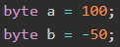
  - short
    - The short data type is a 16-bit signed two's complement integer, which provides a range of values from -32,768 (-2^15) to 32,767 (inclusive) (2^15 -1). Like the byte data type, the short data type is also beneficial for saving memory, as it occupies less space compared to an integer, being only half the size.
    - The default value for a short variable is 0.
    - 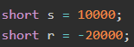
  - int
    - The int data type is a 32-bit signed two's complement integer, allowing for a wide range of values from -2,147,483,648 (-2^31) to 2,147,483,647 (inclusive) (2^31 -1). Here the integer is generally used as the default data type for integral values unless there is a concern about memory.
    - The default value for an int variable is 0.
    - 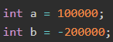
  - long
    - The long data type is a 64-bit signed two's complement integer, capable of representing a vast range of values from -9,223,372,036,854,775,808 (-2^63) to 9,223,372,036,854,775,807 (inclusive) (2^63 -1). This data type is used when a wider range than int is needed, where its default value is 0L.
    - 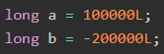
  - float
    - The float data type is a single-precision 32-bit IEEE 754 floating-point representation. It is particularly useful for saving memory in large arrays of floating-point numbers. Its default value is 0.0f. However, it's important to note that the float data type is not suitable for precise values, such as currency, due to potential rounding errors in floating-point arithmetic. Instead, we would use Big Decimal.
    - You must explicitly use f to indicate a float literal
    - If you write a decimal literal like 3.14, it's treated as a double. Assigning it directly to a float without f causes a compilation error:
    - 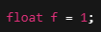 is valid in Java because 1 is an integer literal, and Java allows implicit widening conversions from int to float.
  - double
    - The double data type is a double-precision 64-bit IEEE 754 floating-point representation, which is generally used as the default data type for decimal values, generally the default choice. Double data type should never be used for precise values such as currency, where its default value is 0.0d.
    - Java treats decimal literals as double by default.
    - So, this is valid without the d:
    - There's no need to add d unless for clarity or explicit type declaration.
    - 
    - is valid in Java because 1 is an integer literal, and Java allows implicit widening conversions from int to double.
  - boolean
    - The boolean data type represents a single bit of information and can hold one of two possible values: true or false. This data type is used for simple flags that track true/false conditions where its default value is false.
  - char
    - The char data type is a single 16-bit Unicode character, which represents a wide range of characters from different languages and symbols. With a range '\u0000' (or 0) to '\uffff' (or 65,535 inclusive). This data type is primarily used to store individual characters.
- The non-primitive data types are not predefined. The reference data types are created using defined constructors of the classes. They are used to access objects. These variables are declared to be of a specific type that cannot be changed. For example, Employee, Puppy, etc.
- The following are the non-primitive (reference/object) data types:
  - String: The string is a class in Java, and it represents the sequences of characters.
  - Arrays: Arrays are created with the help of primitive data types and store multiple values of the same type.
  - Classes: The classes are the user-defined data types and consist of variables and methods.
  - Interfaces: The interfaces are abstract types that are used to specify a set of methods.
- The default value of any reference variable is null. A reference variable can be used to refer to any object of the declared type or any compatible type.

String
- Strings, which are widely used in Java programming, are a sequence of characters. In Java programming language, strings are treated as objects.
- The Java platform provides the String class to create and manipulate strings.
- The String class is immutable, so that once it is created a String object cannot be changed. If there is a necessity to make a lot of modifications to Strings of characters, then you should use String Buffer & String Builder Classes.
- 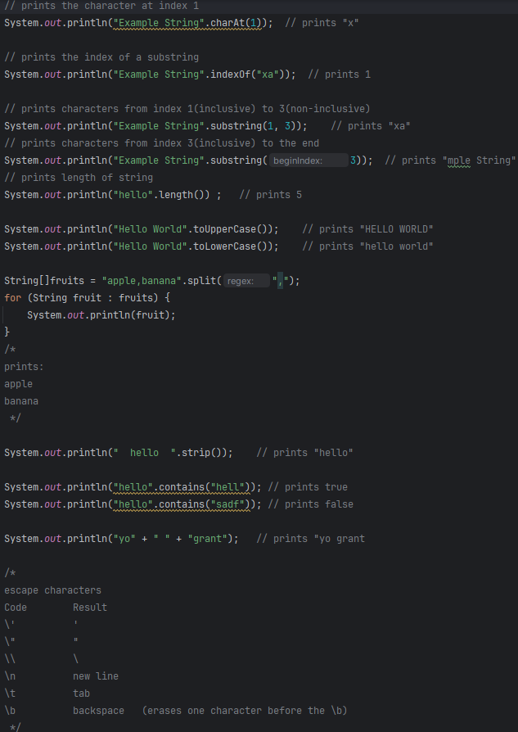
Arrays
- Java provides a data structure called the array, which stores a fixed-size sequential collection of elements of the same data type. An array is used to store a collection of data, but it is often more useful to think of an array as a collection of variables of the same type.
- Declaring Array Variables
  - To use an array in a program, you must declare a variable to reference the array, and you must specify the type of array the variable can reference. Here is the syntax for declaring an array variable:
    - 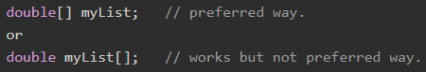
  - Defining array’s length with constant
  - Defining array’s length with variable
    - 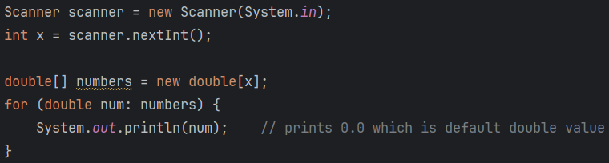
  - Defining initial value of array
    - 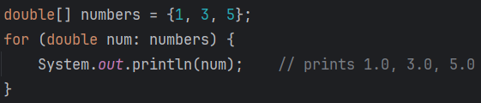
- Modifying array and getting subarray
- 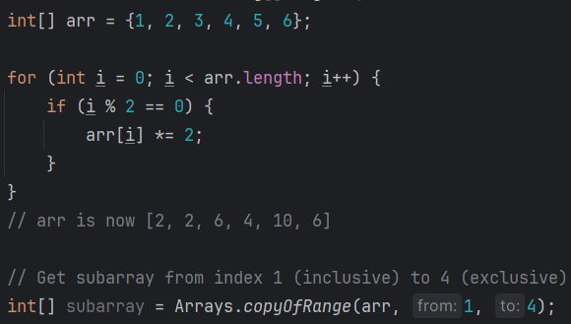
- 2D array
  - 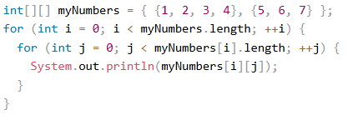

Type Casting
- Type casting is a technique that is used either by the compiler or a programmer to convert one data type to another in Java. Type casting is also known as type conversion. For example, converting int to double, double to int, short to int, etc.
- There are two types of type casting allowed in Java programming:
  - Widening type casting
  - Narrowing type casting
- Here is the hierarchy of type casting in Java:
- Widening type casting
  - Widening type casting is also known as implicit type casting in which a smaller type is converted into a larger type, it is done by the compiler automatically.
  - The compiler plays a role in the type conversion instead of programmers. It changes the type of the variables at the compile time. Also, type conversion occurs from the small data type to large data type only.
  - In this example, we are adding an integer and a double number, storing the result in a double variable to display the sum, implicitly casting the integer to a double during the addition:
    - 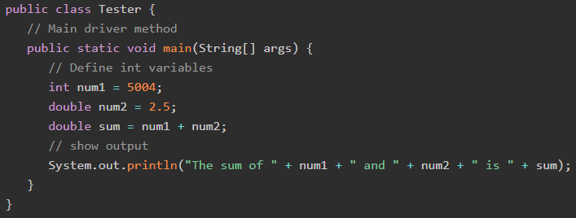
    - Output:
  - Java compiler performs implicit type conversion when assigning values between compatible types, but it does not allow the conversion from a larger data type to a smaller one without explicit type casting.
    - 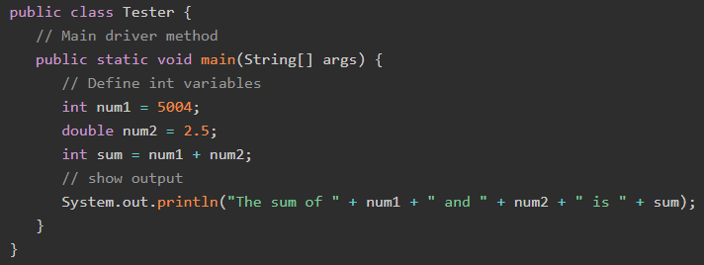
    - Output: 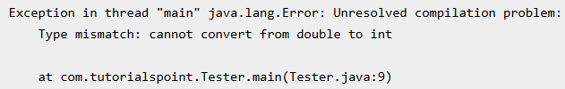
- Narrowing Type Casting
  - Narrowing type casting is also known as explicit type casting or explicit type conversion which is done by the programmer manually. In the narrowing type casting a larger type can be converted into a smaller type.
  - When a programmer changes the variable type while writing the code. We can use the cast operator to change the type of the variable. For example, double to int or int to double.
  - 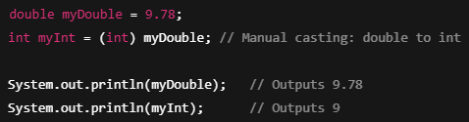
- In narrowing casting (explicit), data can be lost or changed because you're converting from a larger or more precise data type to a smaller or less precise one. Let’s break down how this happens:
  - 1. Loss of Precision (Floating Point → Integer)
    - When converting a floating-point number (e.g., double, float) to an integer type (int, byte, etc.), the decimal/fractional part is discarded.
    - 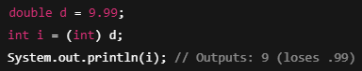
  - 2. Overflow or Underflow (Larger Integer → Smaller Integer)
    - When a value is too large or small to fit in the target type, it wraps around due to overflow or underflow, producing an incorrect result.
    - 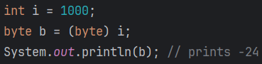
    - Decimal 1000 in binary (32-bit int): 1000 = 00000000 00000000 00000011 11101000
    - Java drops the upper 24 bits and retains the last 8 bits (LSB – least significant byte):
    - When you cast from int to byte, Java takes only the lower 8 bits of the int. In this case:
    - int: 00000000 00000000 00000011 11101000 gets turned into byte: 11101000
    - Convert 11101000 to decimal (2's complement), you get -24
- Type Casting With Objects:
  - In Java, object type casting is also used when dealing with class inheritance:
  - Upcasting (Widening) – Implicit
    - Casting a subclass object to a superclass reference.
    - 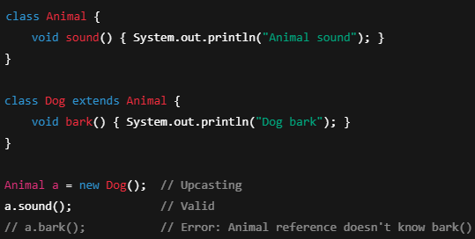
  - Downcasting (Narrowing) – Explicit
    - Casting a superclass reference back to a subclass.
    - 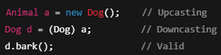
    - Be careful with downcasting. If the object is not actually of the target type, a ClassCastException will be thrown.
Unicode System
- Unicode is an international character set that encompasses a vast range of characters, symbols, and scripts from many languages across the globe.
- Java programming language, being platform-independent, has built-in support for Unicode characters, allowing developers to create applications that can work seamlessly with diverse languages and scripts.
- Before Unicode, there were multiple standards to represent character encoding:
  - ASCII − for the United States.
  - ISO 8859-1 − for Western European Language.
  - KOI-8 − for Russian.
  - GB18030 and BIG-5 − for Chinese.
- So to support multinational application codes, some character was using single byte, some two. An even same code may represent a different character in one language and may represent other characters in another language.
- To overcome above shortcoming, the Unicode system was developed where each character is represented by 2 bytes. As Java was developed for multilingual languages it adopted the Unicode system. The lowest value is represented by \u0000 and the highest value is represented by \uFFFF.
- There are two approaches for working with Unicode characters in Java: Using Unicode Escape Sequences and Directly Storing Unicode Characters.
- The first approach involves representing Unicode characters using escape sequences and is useful when the characters cannot be directly typed or displayed in the Java code. The second approach involves directly storing Unicode characters in variables and is more convenient when the characters can be directly typed or displayed.
- The choice of approach depends on the specific requirements of the program. However, in general, Approach 2 is simpler and more convenient when the characters can be directly typed or displayed, while Approach 1 is necessary when they cannot.
- 1. Using Unicode Escape Sequences
  - One way to store Unicode characters in Java is by using Unicode escape sequences. An escape sequence is a series of characters that represent a special character. In Java, a Unicode escape sequence starts with the characters '\u' followed by four hexadecimal digits that represent the Unicode code point of the desired character.
  - 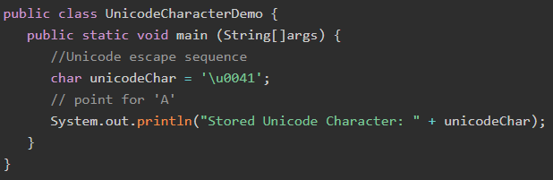
  - Output:
- 2. Storing Unicode Values Directly
  - Alternatively, you can directly store a Unicode character in a char variable by enclosing the character in single quotes. However, this approach may not be feasible for characters that cannot be typed directly using a keyboard or are not visible, such as control characters.
  - 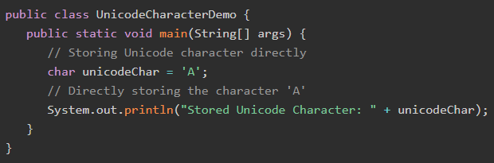
  - Output:

Operators
- Java operators are the symbols that are used to perform various operations on variables and values. By using these operators, we can perform operations like addition, subtraction, checking less than or greater than, etc.
- There are different types of operators in Java, we have listed them below:
  - Arithmetic Operators
    - Arithmetic operators are used in mathematical expressions in the same way that they are used in algebra. The following table lists the arithmetic operators.
    - 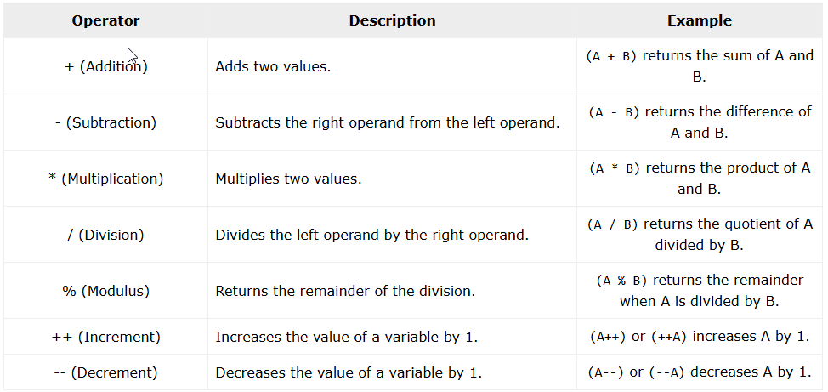
  - Assignment Operators
    - Java assignment operators are used to assign values to variables. These operators modify the value of a variable based on the operation performed. The most commonly used assignment operator is =, but Java provides multiple compound assignment operators for shorthand operations.
    - 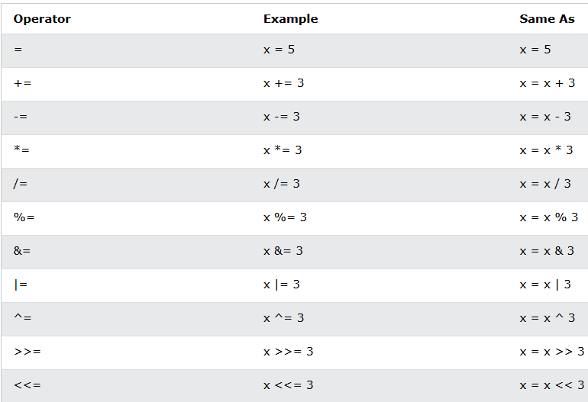
  - Relational Operators
    - Java relational operators are used to compare two values. These operators return a boolean result: true if the condition is met and false otherwise. Relational operators are commonly used in decision-making statements like if conditions and loops.
    - 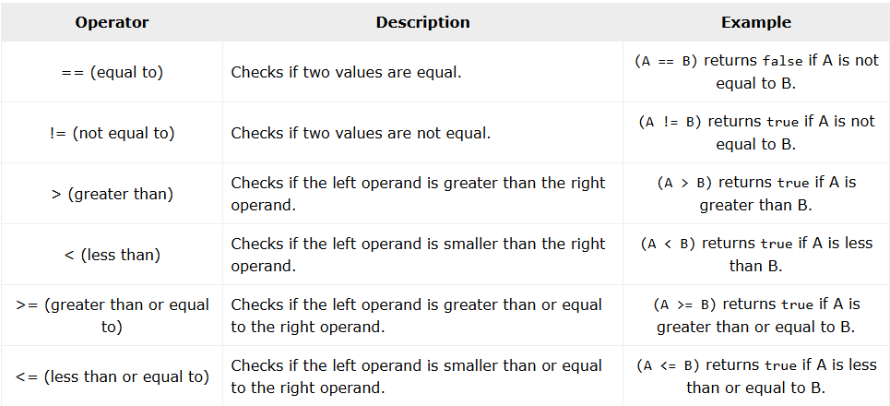
  - Logical Operators
    - Java logical operators are used to perform logical operations on boolean values. These operators are commonly used in decision-making statements such as if conditions and loops to control program flow.
    - 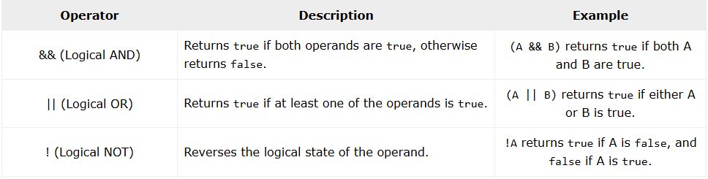
  - Bitwise Operators
    - Java bitwise operators are used to perform operations at the binary (bit) level. These operators work on individual bits of numbers. They are commonly used in low-level programming, encryption, and performance optimization.
    - Java defines several bitwise operators, which can be applied to the integer types, long, int, short, char, and byte.
    - Bitwise operator works on bits and performs bit-by-bit operation. Assume if a = 60 and b = 13; now in binary format they will be as follows:
    - 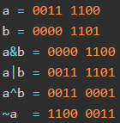
    - Assume integer variable A holds 60 and variable B holds 13 then:
    - 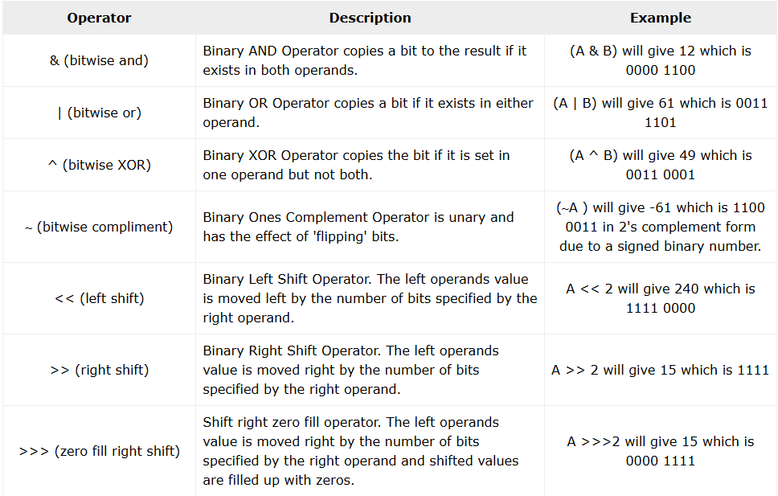
  - Misc Operators
    - There are few other operators supported by Java Language.
    - Conditional Operator ( ? : )
      - Conditional operator is also known as the ternary operator. This operator consists of three operands and is used to evaluate Boolean expressions. The goal of the operator is to decide, which value should be assigned to the variable. The operator is written as:
    - instanceof Operator
      - This operator is used only for object reference variables. The operator checks whether the object is of a particular type (class type or interface type). instanceof operator is written as:
  - Java Operators Precedence & Associativity
    - In Java, operator precedence decides which part of an expression gets evaluated first. If an expression has multiple operators, Java follows a predefined order to solve it. Associativity determines the direction in which operators of the same precedence level are executed.
    - Left to Right Associativity: Operators like +, -, *, /, &&, and || are evaluated from left to right.
    - Right to Left Associativity: Operators like = (assignment) and ?: (ternary operator) are evaluated from right to left.
    - 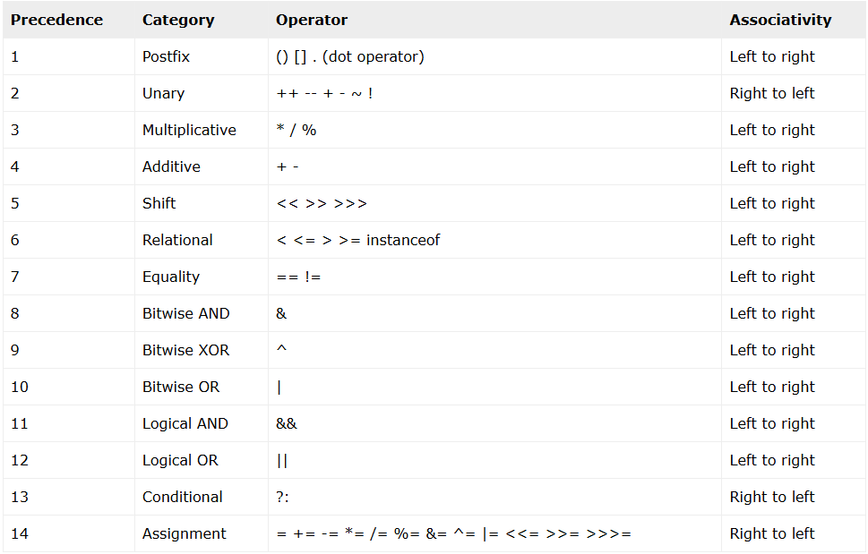
If statement
- 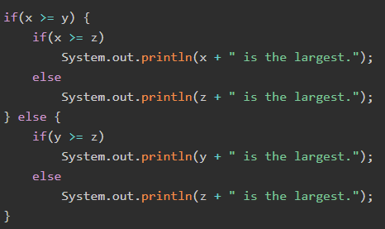
- Curly Braces for Multiple Statements: If there is more than one statement inside if or else, enclose them within { } curly braces.
- Single Statement Optional Braces: If there is only one statement inside if or else, curly braces are optional but recommended for better readability.
Switch Statement
- Java switch statement allows a variable to be tested for equality against a list of values. Each value is called a case, and the variable being switched on is checked for each case.
- The switch statement can be used when multiple if-else statements are required. It can have multiple code blocks along with the case values and execute one of many code blocks based on the matched case value.
- The following rules apply to a switch statement −
  - The variables used in a switch statement can only be integers, convertable integers (byte, short, char), strings, and enums.
  - You can have any number of case statements within a switch. Each case is followed by the value to be compared to and a colon.
  - The value for a case must be the same data type as the variable in the switch, and it must be a constant or a literal.
  - When the variable being switched on is equal to a case, the statements following that case will execute until a break statement is reached.
  - When a break statement is reached, the switch terminates, and the flow of control jumps to the next line following the switch statement.
  - Not every case needs to contain a break. If no break appears, the flow of control will fall through to subsequent cases until a break is reached.
  - A switch statement can have an optional default case, which must appear at the end of the switch. The default case can be used for performing a task when none of the cases is true. No break is needed in the default case.
- 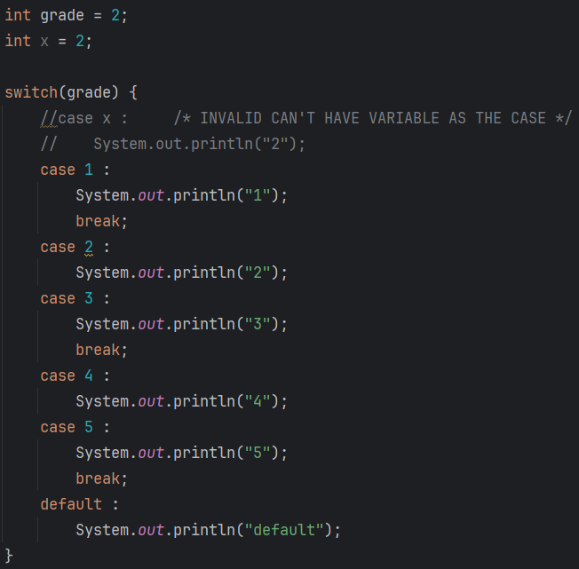
- Output:

